1. **Given the provided data, what are three conclusion we can draw about Kickstarter campaigns?**

Three conclusions that can be drawn from the Kickstarter campaigns are:

1. Of all the 4,114 campaigns from 2009 to 2017, just over half of them (53%) have been successful (i.e. reached their goal funding amount) and 37% of campaigns failed. The remaining 10% were either cancelled or are still live campaigns. It is important to note that not all cancelled campaigns were ineffective as there were five, out of 349, that reached their goal funding amount. In terms of geographical reach, 94% (3,874 out of 4,114) of all the available Kickstarter campaigns occurred in English speaking countries (i.e. AU, CA, GB, NZ, US).
2. Over a third (33.8%) of all campaigns are for theater projects, specifically plays. Theater campaigns are relatively successful with 60% of them hitting their goal amount. For the plays sub-category, 65% of campaigns are successful, while 33% of them have failed and the remaining 2% are live. The category with the lowest amount of campaigns is journalism, with only 24 projects, all of which were cancelled.
3. Upon investigating the date created, the first Kickstarter campaigns in our data were started in May 2009. From 2009 to the end of 2013, there was a slow growth in the number of campaigns on the Kickstarter platform and it wasn’t until 2014 that there was a boom in the number of projects. For instance, in 2013, 274 campaigns were started while 976 new campaigns began in 2014, which is a year-over-year growth of 256%. From 2014 onward, there has been approx. 1,000 new campaigns a year. When it comes to the campaign outcome (i.e. state) and the month that a campaign starts, the data indicates that projects starting in Q2 (April through June) have a higher possibility of being successful (58% in the quarter). While there is also a spike in successful campaigns started in October and November, those months also have a larger chance of failing campaigns (i.e. average of 51% successful outcomes and 42% failed for October and November).
4. **What are some limitations of this dataset?**

Potential limitations of this dataset include incomplete information/data. Since we were provided this data with no known source, we have no idea if these is a set of all Kickstarter campaigns from 2009 to 2017 or if this is just a subset of campaigns. If this is a subset, there is potential bias as we do not know if these campaigns were chosen at random or if they were chosen deliberately.

Another limitation is that we were not provided with definitions behind the column names and their entries. For instance, in the “state” column, there are four categories: successful, failed, canceled and live. Does a successful campaign mean that it was completed by its end date and that it achieved its goal amount? Does a canceled campaign imply that it failed to either reach its goal amount by its designated end date or was it canceled by the owner of the campaign? In looking at the data, it seems that there were canceled campaigns that were fully funded. Would this not mean that they were successful or was there additional issues besides funding that caused the project cancelation? Other columns that require better definitions include spotlight and staff_pick.

1. **What are some other possible tables and/or graphs that we could create?**

Other possible tables that we could create include:

* Comparing campaign outcome and the length of time of the campaign, where length is the difference between Date Ended and Date Created



* Comparing campaign outcome to if the campaign was a staff pick (i.e. staff_pick as rows)



* Given that the campaign was a staff pick (i.e. filter on staff_pick = TRUE), comparing campaign outcome to categories and subcategories

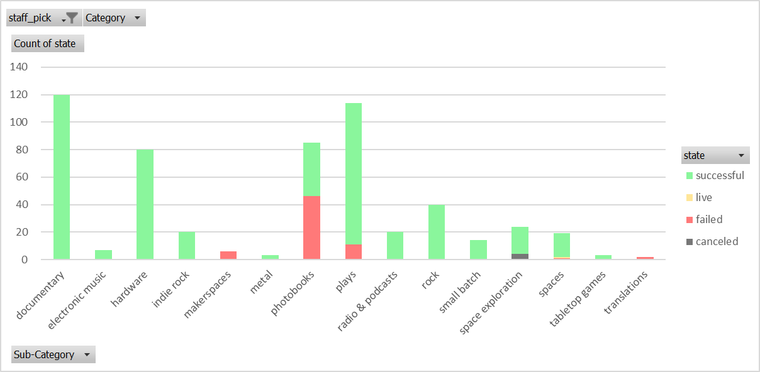

* Looking at the average backing amount, which I created separately using a calculated field where average backing amounts = pledged / backer_count, of a specific category and comparing it to campaign’s outcome



* Comparing campaign outcome to its average percent funded by category

